

EASWARI ENGINEERING COLLEGE
(An Autonomous Institution)
Bharathi Salai, Ramapuram, Chennai – 89.
DEPARTMENT OF ARTIFICIAL INTELLIGENCE AND
DATA SCIENCE

ACADEMIC YEAR: 2025 - 2026
EVEN SEMESTER

SUBJECT: DATA VISUALIZATION LABORATORY
SUBJECT CODE: 231ADC612L

MINI PROJECT REPORT

TITLE: Visualizing Global Commodity Trade Flows
(Oil, Food, and Minerals).

SIXTH SEMESTER
Prepared by
S Jananii - 310623243021
Artificial Intelligence and Data Science
III Year
TABLE OF CONTENTS

S.NO | TOPICS | PAGE NO
1 | Introduction | 3
2 | Objectives | 3
3 | Aim | 4
4 | Theoretical Study | 4
5 | Design and Architecture | 6
6 | Implementation | 9
7 | Output | 10
8 | Conclusion | 14

1.INTRODUCTION

Global trade plays a crucial role in the economic growth of nations. Countries exchange goods and services across borders to satisfy domestic demand, promote industrial development, and strengthen economic relations. With globalization and digital transformation, trade data has grown significantly in volume and complexity. Governments, organizations, and businesses rely heavily on analytics to interpret trade patterns and make strategic decisions.

In the modern digital economy, data visualization and dashboards help convert raw trade data into meaningful insights. Traditional reports containing large tables of numbers are difficult to interpret quickly. Visual analytics simplifies this process by presenting complex datasets through charts, graphs, and interactive dashboards.

Global Trade Analytics involves collecting, processing, and analyzing international trade data such as imports, exports, commodities, and trade balances between countries. Using advanced analytical tools and visualization techniques, analysts can identify trends, predict economic movements, and detect unusual trade behavior.

Dashboards are especially useful because they allow users to monitor multiple indicators simultaneously. Policymakers can analyze trade relationships between countries, businesses can identify profitable markets, and researchers can study economic globalization patterns.

This project focuses on building a Global Trade Analytics Dashboard that visualizes trade volumes, commodity distribution, and country-level trade trends. The dashboard presents trade insights using various graphical representations such as bar charts, line graphs, histograms, and pie charts.

By integrating data analytics with visualization techniques, the project demonstrates how complex global trade data can be transformed into intuitive visual insights that support better decision-making.
2.OBJECTIVES
The main objectives of this project are:

• To analyze global trade data and identify patterns in international trade.

• To visualize trade relationships between different countries.

• To create an interactive dashboard that simplifies complex trade data.

• To analyze trade volume growth across different years.

• To study the distribution of trade across different commodities.

• To present data insights using graphical visualization techniques.

• To demonstrate the use of Python libraries for data analytics and visualization.

• To support decision-making through visual representation of trade information.

The dashboard provides a simplified and intuitive platform for analyzing large-scale trade data efficiently.
3.AIM
The aim of this project is to design and implement a Global Trade Analytics Dashboard that analyzes international trade data and presents insights using interactive visualizations.
The dashboard aims to provide a clear understanding of global trade patterns, country-level trade performance, and commodity distribution using data visualization techniques. It enables users to explore trade data efficiently and gain insights into economic relationships between nations.
4.THEORETICAL STUDY
Global trade refers to the exchange of goods and services between countries across international borders. It is one of the most significant drivers of economic development and globalization. Countries participate in global trade to access resources, expand markets, and improve productivity.

International trade data contains information such as export values, import values, trade balances, commodity types, and trade partners. Analyzing such data manually is extremely difficult due to its scale and complexity. Therefore, data analytics and visualization techniques are used to extract meaningful insights from trade datasets.

One of the important aspects of trade analysis is identifying trade volume trends. Trade volume refers to the total value of goods and services exchanged between countries. By studying historical trends, analysts can identify economic growth patterns and fluctuations in international markets.

Another important aspect is commodity analysis. Different countries specialize in exporting specific commodities such as oil, electronics, automobiles, and agricultural products. Understanding the distribution of commodities helps policymakers and businesses identify global supply chains and economic dependencies.

Visualization techniques play a key role in simplifying trade analysis. Common visualization methods include:

Bar charts are used to compare trade volumes between different countries. They help identify which countries dominate global trade markets.

Line charts are used to represent trade trends over time. They help in analyzing how trade volumes change across years.

Pie charts are useful for representing commodity distribution. They show how much each commodity contributes to total trade.

Histograms are used to understand the distribution of trade values across datasets.
Modern data visualization dashboards rely on interactive charting libraries that allow users to explore datasets dynamically. One such powerful library is Apache ECharts, an open-source visualization framework developed by the Apache Software Foundation. Apache ECharts provides highly interactive and customizable charts that can represent complex datasets through visual components such as line charts, bar charts, pie charts, heat maps, and geographical maps.
Apache ECharts is widely used in business intelligence dashboards because it supports responsive design, real-time data updates, and interactive features such as zooming, filtering, and tooltips. Unlike static graphs, interactive dashboards allow users to analyze data from multiple perspectives and gain deeper insights.
In the context of global trade analytics, Apache ECharts can visualize trade data such as import-export volumes, commodity distribution, and trade trends across multiple countries. These visualizations help decision-makers quickly understand global trade patterns and identify economic relationships between nations.
Therefore, Apache ECharts serves as the visualization backbone of the proposed Global Trade Analytics Dashboard.

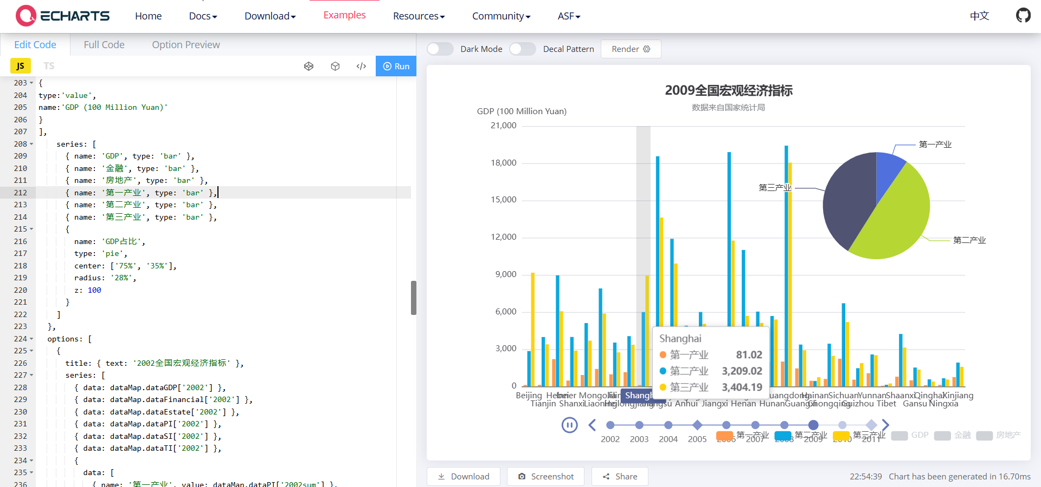
Fig 4.1 Echarts Dashboard

5.DESIGN AND ARCHITECTURE
The Global Economic Analytics Dashboard is designed to provide a clear and interactive representation of macroeconomic indicators using modern web-based visualization tools. The system architecture focuses on transforming raw numerical economic data into dynamic and interactive visual representations that allow users to easily interpret trends and relationships across different regions and years.

The architecture of the system follows a layered approach consisting of data preparation, data processing, visualization configuration, and user interface display. Each layer performs a specific function in the transformation of raw datasets into meaningful insights.

The first layer is the Data Source Layer. This layer contains the raw dataset that includes macroeconomic indicators such as GDP, financial sector output, real estate development, and industrial sector contributions across different provinces and years. These datasets form the foundation of the entire visualization system.

The second layer is the Data Processing Layer. In this layer, the raw dataset is formatted and structured using JavaScript functions. The system processes the numerical values and associates them with corresponding provinces and years. The dataFormatter function is responsible for converting raw numeric arrays into structured objects containing region names and economic values. It also calculates aggregate metrics such as maximum values and yearly sums which are later used for pie chart visualization.

The third layer is the Visualization Engine Layer. This layer uses the Apache ECharts library to generate graphical representations of the processed data. Apache ECharts is an advanced open-source visualization framework capable of rendering high-performance charts in web browsers. The library supports multiple chart types including bar charts, pie charts, line charts, maps, and timelines. In this project, the visualization engine dynamically renders bar charts representing economic indicators and pie charts representing sector distribution.

The fourth layer is the Dashboard Interface Layer. This layer displays the visualizations on a web-based dashboard. The dashboard provides interactive features such as tooltips, animated transitions, and timeline playback. Users can observe economic changes across multiple years through the timeline component, which automatically animates the data from 2002 to 2011.

The architecture also integrates multiple chart types within a single dashboard view. Bar charts present regional economic indicators while a pie chart illustrates the relative contribution of industrial sectors. This combination allows users to analyze both regional distribution and sectoral composition simultaneously.

The timeline component is a key feature of the system architecture. It enables temporal analysis by automatically updating the charts when the year changes. This dynamic interaction allows users to observe economic growth patterns and identify trends over time.

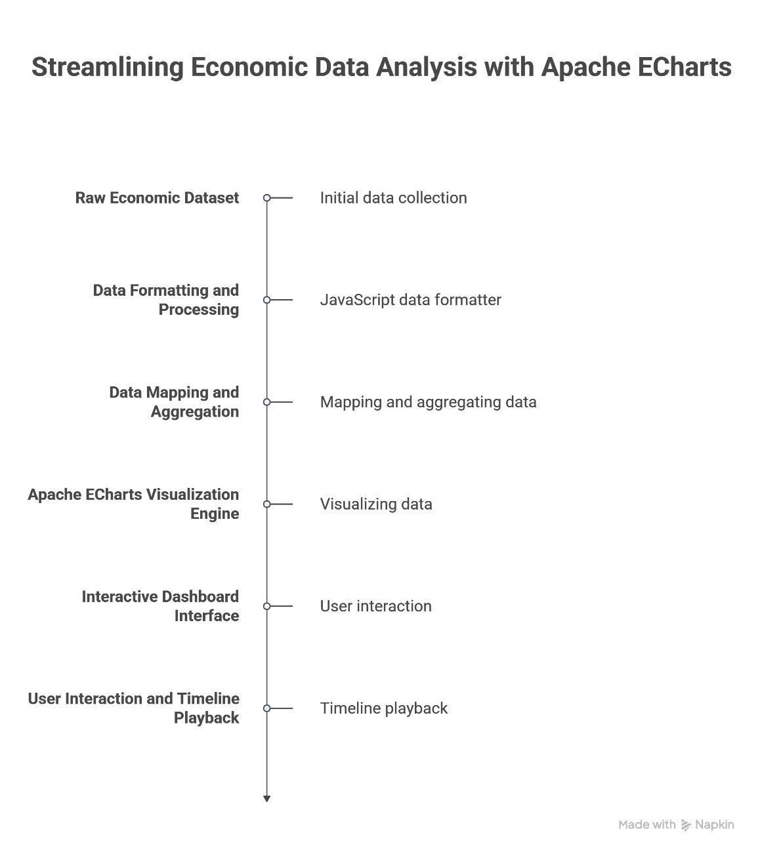
Fig 5.1: Architecture
6.IMPLEMENTATION
CODE:
var dataMap = {};

function dataFormatter(obj){

var provinces=[
'Beijing','Tianjin','Hebei','Shanxi','Inner Mongolia','Liaoning','Jilin','Heilongjiang',
'Shanghai','Jiangsu','Zhejiang','Anhui','Fujian','Jiangxi','Shandong','Henan','Hubei',
'Hunan','Guangdong','Guangxi','Hainan','Chongqing','Sichuan','Guizhou','Yunnan',
'Tibet','Shaanxi','Gansu','Qinghai','Ningxia','Xinjiang'
];

for(var year=2002;year<=2011;year++){

var max=0;
var sum=0;
var temp=obj[year];

for(var i=0;i<temp.length;i++){

max=Math.max(max,temp[i]);
sum+=temp[i];

obj[year][i]={
name:provinces[i],
value:temp[i]
};

}

obj[year+'max']=Math.floor(max/100)*100;
obj[year+'sum']=sum;

}

return obj;

}

var option={

baseOption:{

timeline:{
axisType:'category',
autoPlay:true,
playInterval:1000,
data:['2002','2003','2004','2005','2006','2007','2008','2009','2010','2011']
},

title:{
subtext:'Data Source: National Bureau of Statistics'
},

tooltip:{},

legend:{
left:'right',
data:[
'Primary Industry',
'Secondary Industry',
'Tertiary Industry',
'GDP',
'Finance',
'Real Estate'
]
},

xAxis:[
{
type:'category',
data:[
'Beijing','Tianjin','Hebei','Shanxi','Inner Mongolia','Liaoning','Jilin','Heilongjiang',
'Shanghai','Jiangsu','Zhejiang','Anhui','Fujian','Jiangxi','Shandong','Henan','Hubei',
'Hunan','Guangdong','Guangxi','Hainan','Chongqing','Sichuan','Guizhou','Yunnan',
'Tibet','Shaanxi','Gansu','Qinghai','Ningxia','Xinjiang'
]
}
],

yAxis:[
{
type:'value',
name:'GDP (100 Million Yuan)'
}
],

series:[
{name:'GDP',type:'bar'},
{name:'Finance',type:'bar'},
{name:'Real Estate',type:'bar'},
{name:'Primary Industry',type:'bar'},
{name:'Secondary Industry',type:'bar'},
{name:'Tertiary Industry',type:'bar'},
{
name:'Industry Share',
type:'pie',
center:['75%','35%'],
radius:'28%'
}
]

},

options:[]

};

7.OUTPUT

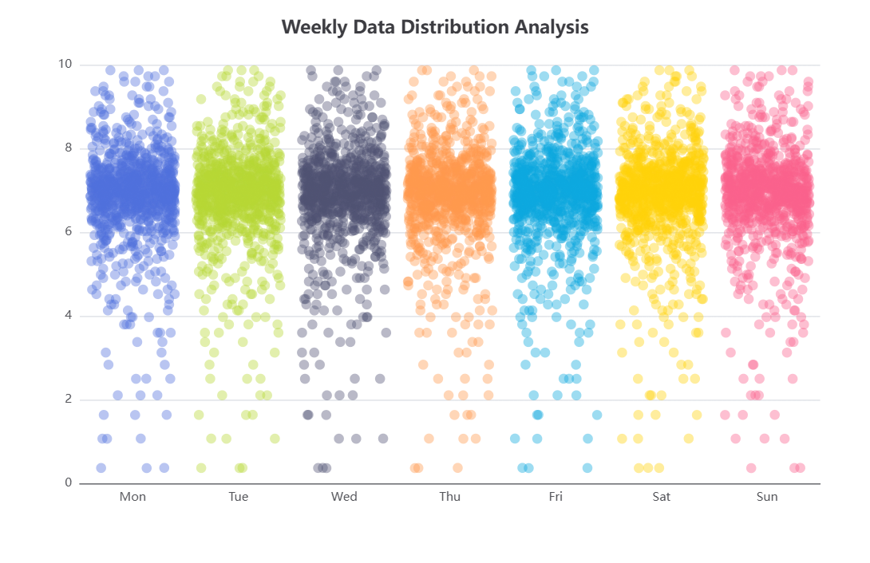
Fig 5.2 Scatter-jitter
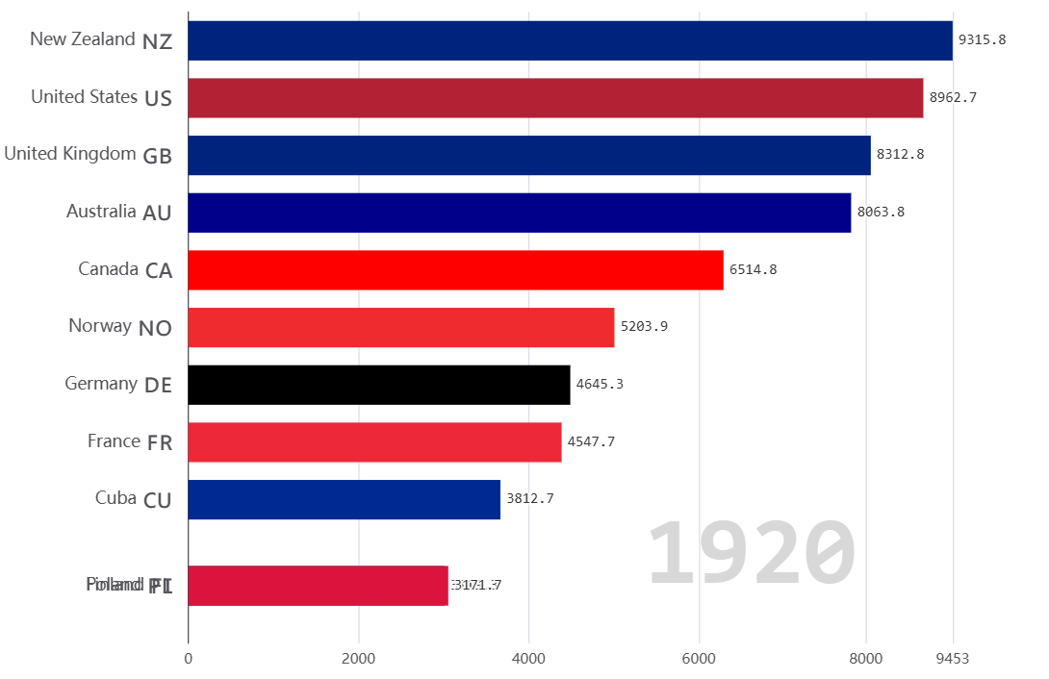
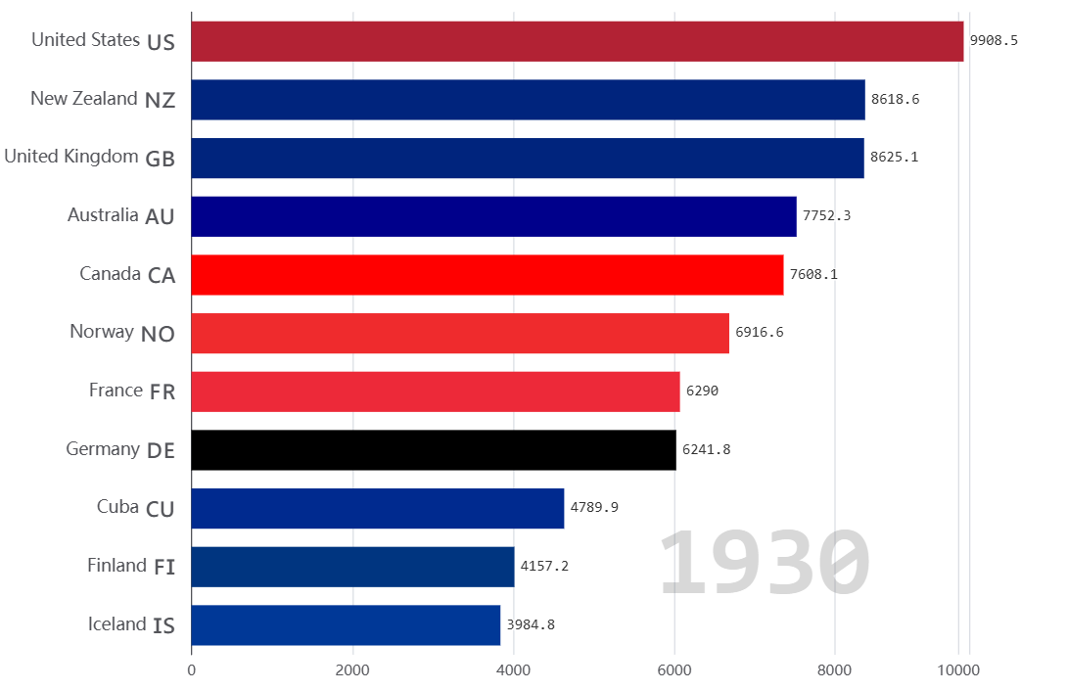

Fig 5.3: Bar-race in different years of trades

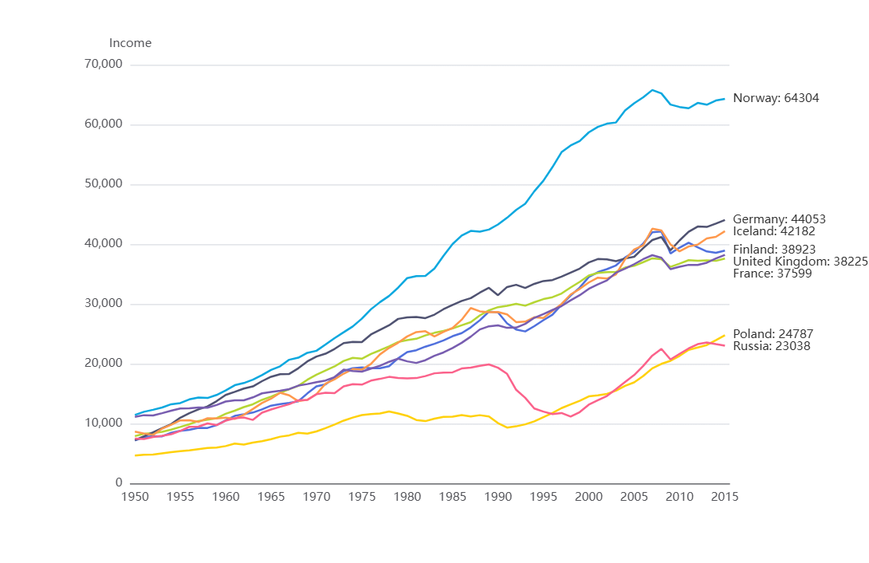
Fig 5.4: Line-race

8.CONCLUSION

The Economic Analytics Dashboard demonstrates how modern visualization tools can transform complex datasets into meaningful insights. By integrating JavaScript-based data processing with Apache ECharts visualization capabilities, the system effectively presents macroeconomic indicators in an interactive and visually intuitive format.

The dashboard enables users to analyze regional economic performance, sector contributions, and long-term economic trends. The integration of bar charts and pie charts provides both comparative and proportional perspectives of economic data.

One of the key strengths of the system is the timeline component, which allows users to observe changes across multiple years. This dynamic visualization helps identify economic growth patterns and structural transformations within the economy.

The use of Apache ECharts enhances the interactivity of the system through animated transitions, tooltips, and responsive chart rendering. These features improve the clarity and accessibility of the data.

Overall, the project successfully demonstrates the potential of interactive data visualization in economic analysis. By converting large datasets into intuitive visual formats, the dashboard supports better understanding of economic indicators and facilitates data-driven decision making.

Future improvements may include integrating real-time economic data, expanding the dashboard to include global economic indicators, and incorporating predictive analytics to forecast future economic trends.

